Crystal Viewer VR

1st Stage – Christmas 2016 (guideline, project is expected to change) – Crystal Viewer

* Remember chemistry classes, the models that were passed around in class (see image below)
* 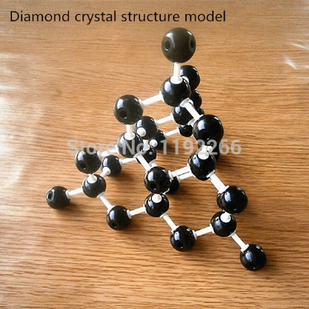
* I am planning to reproduce this, but in Virtual Reality (both google cardboard and Samsung Gear – possible need for game controller to use)
* We shall be using Unity as our developing environment (FREE!): <https://unity3d.com/>
* A nice course is on udemy (not Free! £20): https://www.udemy.com/unitycourse/learn/v4/
* Coding is in C#
* The interface will be modelled in a similar way to Crystal Maker® <http://www.crystalmaker.com/>
* However, I don’t like it very much. There are far too many options. It is confusing to figure out how it works. A much simpler interface is required.
* There is a free version to play with, eventually functionality like the full version would be cool.
* Rotation of the crystal and ability to input coordinates are required
* The code will be split into two, a demo version and a platform version:

Demo

* + With only one input file and basic environment/user interface (like scientific code)
  + Simple spheres, no ‘bonds’
  + I will mainly be working on this for proof of concept purposes

Platform

* + Able to interpret multiple input files (any .cif should be readable)
  + Full user interface: Title scene etc.
  + Example files
  + Full rotation control with information on direction
  + More features to be discussed with the team…
* User interface for Crystal Maker:

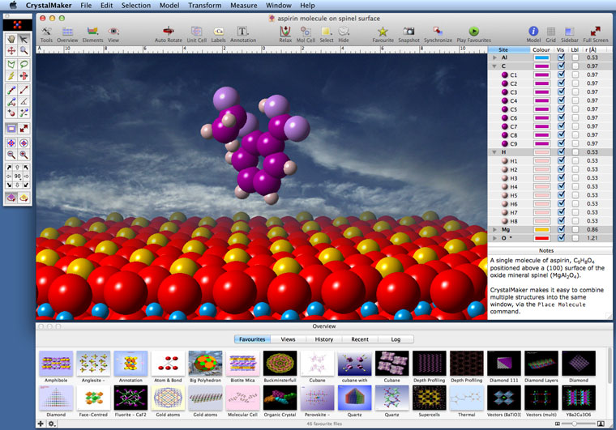

* Hopefully by Christmas 2016 we should have our first working demo version.

2nd Stage – Christmas 2017 – Virtual Microscope

* The main project will remain the crystal viewer 🡪 virtual microscope
  + First task in the year will be to release the first version of the crystal viewer VR
  + Platform should then be stable enough to build a demo of the virtual microscope – completion of demo approx. mid 2017
  + Completion of virtual microscope approx. Christmas 2017
* Also possibility for divergence at this stage
* Major Discussion must then be held on direction of the project. There are many possibilities:
  + Bare minimum is working crystal viewer for thesis
  + Crystal building interface
  + Augmented reality inclusion
  + Implement Virtual microscope (electron, X-ray, light)
  + Refinement (based on my research)
  + Educational, aimed at school children (using google cardboard)
  + More physics/biology/chemistry/computer science features implemented
  + Possibility to go commercial – try to undercut Crystal Maker in the VR business
  + Many more possibilities

3rd Stage – Christmas 2018 – Software package

* 2018 main aim is to release the desired software package in the format decided
* Open ended depending on market for project
* For any release, a proper team of coders must be acquired, either company or large open source base